Even Semester (2022)



**BINUS UNIVERSITY**



**BINUS INTERNATIONAL**



Store programme with UCanAccess

**Student Information**: **Surname**  **Given Names Student ID Number**

1. Phangandy Daniel 2501990312

**Course Code**  **:** COMP6699001   **Course Name**  **:** Object Oriented Programming

**Class**  **:** L2AC   **Name of Lecturer(s)**  **:** Jude Joseph Lamug Martinez

**Major**  **:** Computer Science

**Title of Assignment** : Store programme with UCanAccess

**Type of Assignment**  **:** Final Project

**Submission Pattern**

**Due Date**  **:**  10 June 2022   **Submission Date**  **:**

The assignment should meet the below requirements.

1. Assignment (hard copy) is required to be submitted on clean paper, and (soft copy) as per lecturer’s instructions.
2. Soft copy assignment also requires the signed (hardcopy) submission of this form, which automatically validates the softcopy submission.
3. The above information is complete and legible.
4. Compiled pages are firmly stapled.
5. Assignment has been copied (soft copy and hard copy) for each student ahead of the submission.

# Plagiarism/Cheating

BiNus International seriously regards all forms of plagiarism, cheating and collusion as academic offenses which may result in severe penalties, including loss/drop of marks, course/class discontinuity and other possible penalties executed by the university. Please refer to the related course syllabus for further information.

# Declaration of Originality

By signing this assignment, I understand, accept and consent to BiNus International terms and policy on plagiarism. Herewith I declare that the work contained in this assignment is my own work and has not been submitted for the use of assessment in another course or class, except where this has been notified and accepted in advance.

Signature of Student: Daniel Eric Phangandy

**“Store programme with UCanAccess”**

**Name : Daniel Eric Phangandy**

**ID : 2501990312**

## I. Program Description

This is a simple Store simulation programme made in Java with the Java JDBC Driver UCanAccess to read and write Microsoft Access Databases.

The Microsoft Access Database holds information such as user ID, Name, password and also user type (type 1 being a customer and type 2 being a supervisor). The Database also stores the information of the Store’s item’s ID, its name the stock amount and also the stock price

## II. Class Diagram

## III. Code Explanation

**A. Classes**

1. People Class

People class that will be used in the code

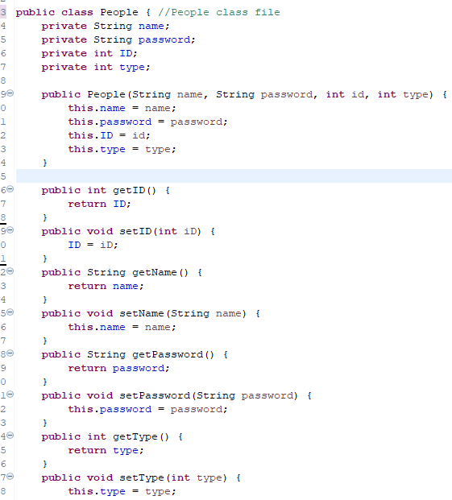

## 2. Stock class

## Stock class that will be used in the code

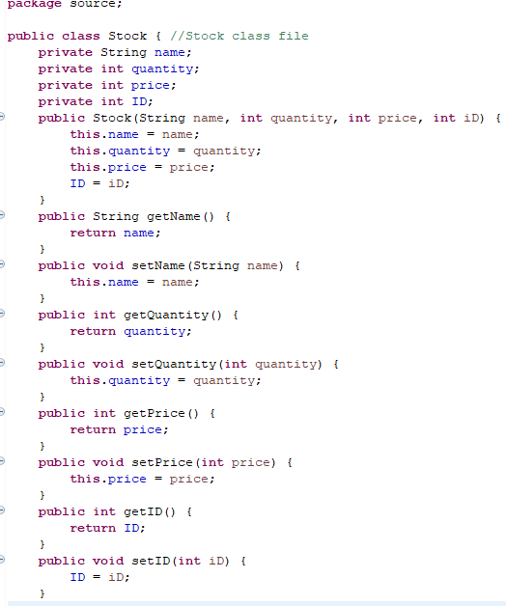

3. Shop Interface

Interface that will be implemented into the ShopServices class

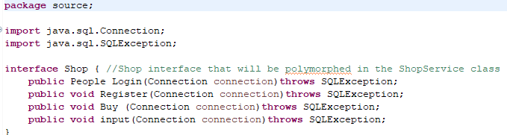

4. ShopServices class

The ShopServices class is the class containing all the main functions that run the program.

**B. Functions**

1. Login Function

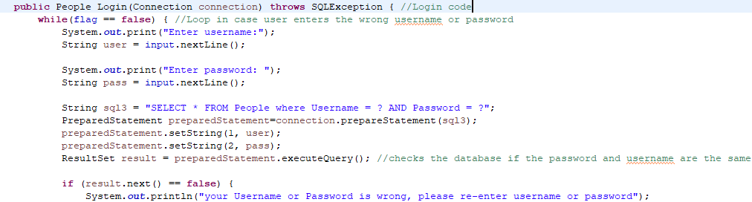The Login function is the function that will be called when the user wants to login to an existing account within the shop’s database

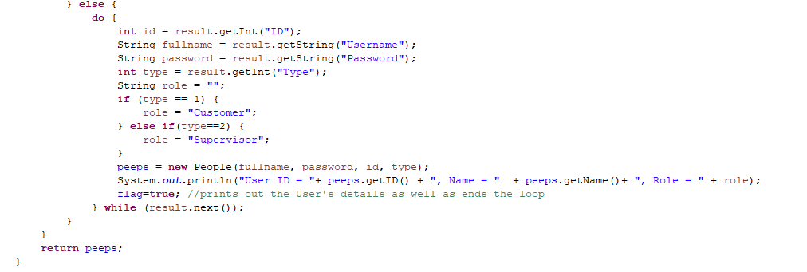Within this function, it will ask the user to input their username and password and matches it with the database, including a while loop in case the user enters an incorrect password or a username that is not within the database. Afterwards it will then print out the user’s information and assign them the role ‘Customer’ or ‘Supervisor’. The code then returns a People class

2. Register Function

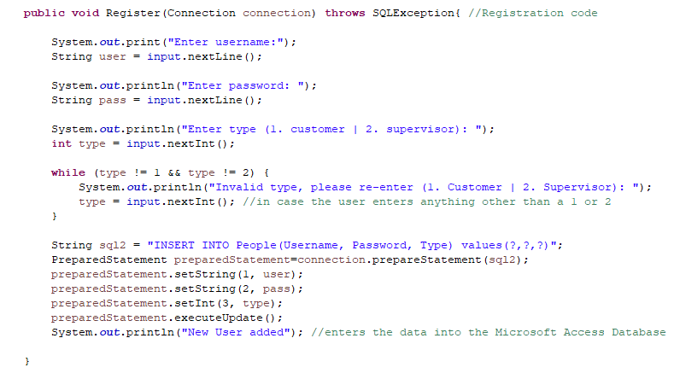The Register function is when a user wants to register themselves into the store’s database

## This function will ask the user for their username, password and user type that they will be registered as, after which it will then be inserted into the Microsoft Access Database

3. Buy Function

The buy function is for when users want to buy from the store.

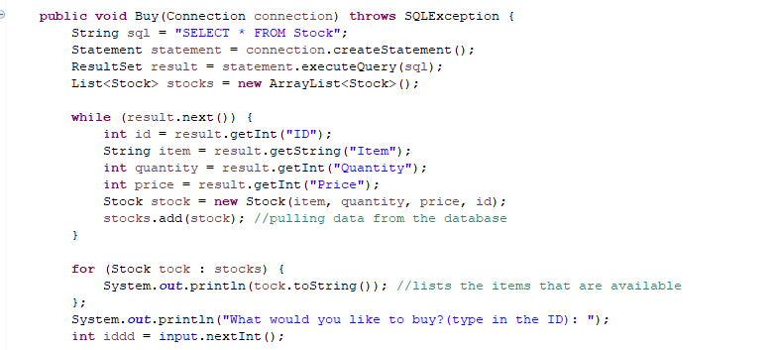It will first print out the items from the database and how much there are in the stock, afterwards it will then ask the user what they would like to buy, which will prompt the user to type in the ID of the item

## Afterwards, the code will check the database for the item’s ID and then ask the user how much of the item do they want to buy, if the user’s input exceeds the stock in the database the code will loop and ask the user to re-enter a valid value. Once the user inputs a valid value, it will then subtract the quantity of the stock by the value the user inputted.

4. Input Function

The input function is only for Supervisors (users of type 2), used when they want to edit the database and add stocks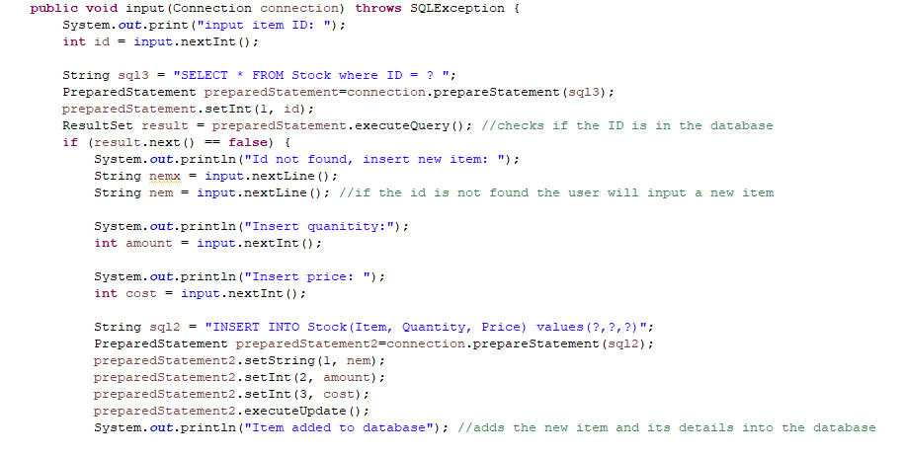

## The user will be asked to enter the ID of an item. If the ID is not found, the code will ask the user to input a new item alongside its name, quantity and price which will then be added to the Database

## If the ID that the user inputs is found, the code will then ask the user for another input of how much of that stock do they want to add.

C. Main file

This is where the code is run, calling from all the classes and using all the functions that were created

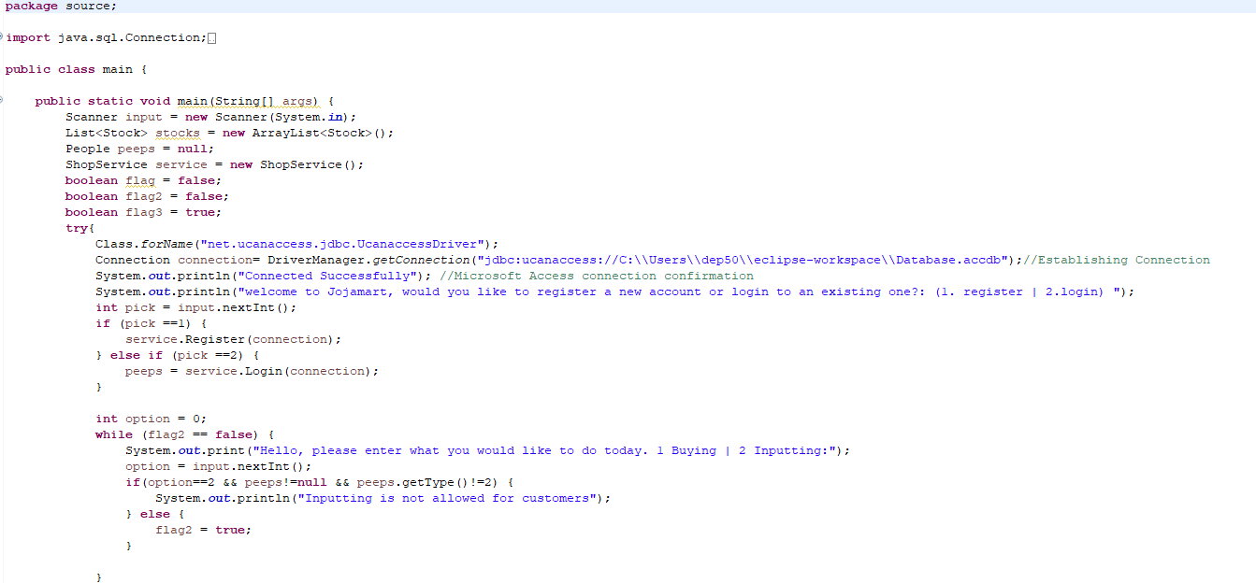At the start, it establishes a connection to the Microsoft Access Database for the code to run, after that it will print out a welcome message and ask the user if they want to register or log in by entering 1 or 2 which will then call in the register and login functions respectively. After the user finishes registering or logging in, the code will then ask the user if they want to buy or input items, however if the user is a customer and not a supervisor the code will not allow the user to use the input function.

## The code will then call the buy function or the input function depending on the user’s input. It is run within a while loop in case the user wants to buy or add more items

## IV. Project Link

https://github.com/DreemGoat/OOP-Final-Project

V. Resources

<https://stackoverflow.com/>